## Supporting Documentation Workshop

## This is a cooking only establishment that produces roast beef that averages 6 lbs. after cooking. The roasts are rubbed with seasoning, racked, and roasted in an oven that has continuous oven temperature monitoring charts.

**HACCP Plan - Fully Cooked Not Shelf Stable Roast Beef**

|  |  |  |  |  |  |
| --- | --- | --- | --- | --- | --- |
| **CCP** | **Critical Limits** | **Monitoring Procedures** | **HACCP**  **Records** | **Verification Procedures** | **Corrective Actions** |
| 2 RB  Cooking | Internal temperature 150 º F for 67 sec.  Time and temperature sufficient to achieve 6.5 log reduction in  *E. coli* as indicated in validated time and temperature tables in Lethality Compliance Guidelines 2021 | QA will replace charts on each oven daily.  QA will take internal temperatures of 10 roasts in every batch that exits the oven.  A batch is defined as each oven. | Oven temperature/ time recording charts  Product temperature log for each oven (batch)  Thermometer calibration log  Corrective action log | Maintenance supervisor will verify accuracy of the oven temperature/ time recording charts once per shift.  QA supervisor will observe QA technician perform monitoring activities once per shift.  QA will check daily before the start of operations all thermometers used for monitoring and verification and calibrate to within 2°F accuracy as necessary | Per 417.3 |

a. Make a list of all the supporting documentation you would request for this process.

b. Use the Lethality Compliance Guidelines 2021 to compare this process to its support. What concerns do you have?

* 1. A plant producing fully cooked turkey loaves is using 150 degrees F. for 72 seconds as its lethality critical limit for *Salmonella* spp. They offer Lethality Compliance Guidelines 2021as support. What concerns do you have?

Applicable Regulations

§ 318.17 Requirements for the production of cooked beef, roast beef, and cooked corned beef products.

1. Cooked beef, roast beef, and cooked corned beef products must be produced using processes ensuring that the products meet the following performance standards:
2. *Lethality.* A 6.5-log10 reduction of *Salmonella* or an alternative lethality that achieves an equivalent probability that no viable *Salmonella* organisms re- main in the finished product, as well as the reduction of other pathogens and their toxins or toxic metabolites necessary to prevent adulteration, must be demonstrated to be achieved through- out the product. The lethality process must include a cooking step. Con- trolled intermediate step(s) applied to raw product may form part of the basis for the equivalency.
3. *Stabilization.* There can be no multiplication of toxigenic microorganisms such as *Clostridium botulinum,* and no more than 1-log10 multiplication of *Clostridium perfringens* within the product.
4. For each product produced using a process other than one conducted in accordance with the Hazard Analysis and Critical Control Point (HACCP) system requirements in part 417 of this chapter, an establishment must develop and have on file and available to FSIS, a process schedule, as defined in § 301.2 of this chapter. Each process schedule must be approved in writing by a process authority for safety and efficacy in meeting the performance standards established for the product in question. A process authority must have access to the establishment in order to evaluate and approve the safety and efficacy of each process schedule.
5. Under the auspices of a processing authority, an establishment must validate new or altered process schedules by scientifically supportable means, such as information gleaned from the literature or by challenge studies con- ducted outside the plant.

**§ 381.150 Requirements for the production of fully cooked poultry products and partially cooked poultry breakfast strips.**

(a) Fully cooked poultry products must be produced using processes ensuring that the products meet the following performance standards:

(1) *Lethality*. A 7-log10 reduction of *Salmonella* or an alternative lethality that achieves an equivalent probability that no viable Salmonella organisms remain in the finished product, as well as the reduction of other pathogens and their toxins or toxic metabolites necessary to prevent adulteration, must be demonstrated to be achieved throughout the product. The lethality process must include a cooking step. Controlled intermediate step(s) applied to raw product may form part of the basis for the equivalency.

(2) *Stabilization*. There can be no multiplication of toxigenic microorganisms such as Clostridium botulinum, and no more than a 1 log10 multiplication of *Clostridium perfringens* within the product.

(b) Partially cooked poultry breakfast strips must be produced using processes ensuring that the products meet the performance standard listed in paragraph (a)(2) of this section. Labeling for these products must comply with § 381.125. In addition, the statement ‘‘Partially Cooked: For Safety, Cook Until Well Done’’ must appear on the principal display panel in letters no smaller than 1⁄2 the size of the largest letter in the product name. Detailed cooking instructions shall be provided on the immediate container of the products.

(c) For each product produced using a process other than one conducted in accordance with the Hazard Analysis and Critical Control Point (HACCP) system requirements in part 417 of this chapter, an establishment must develop and have on file, available to FSIS, a process schedule, as defined in § 381.1(b). Each process schedule must be approved in writing by a process authority for safety and efficacy in meeting the performance standards established for the product in question. A process authority must have access to an establishment in order to evaluate and approve the safety and efficacy of each process schedule.

(d) Under the auspices of a processing authority, an establishment must validate new or altered process schedules by scientifically supportable means, such as information gleaned from the literature or by challenge studies conducted outside the plant.

**Table 2. Time-Temperature Combinations for Meat Products to Achieve Lethality** Temperatures stated are the minimum internal temperatures that must be met in all parts of the meat product for the total dwell time listed.5 An establishment must ensure both time and temperature parameters are met to use this table to support its process achieves the Log reduction target. **Relative humidity**6 and heating **come-up-time (CUT)7** are also **critical operating parameters** when using this table. (See pages 37 and 38 for poultry endpoint time- temperature tables).

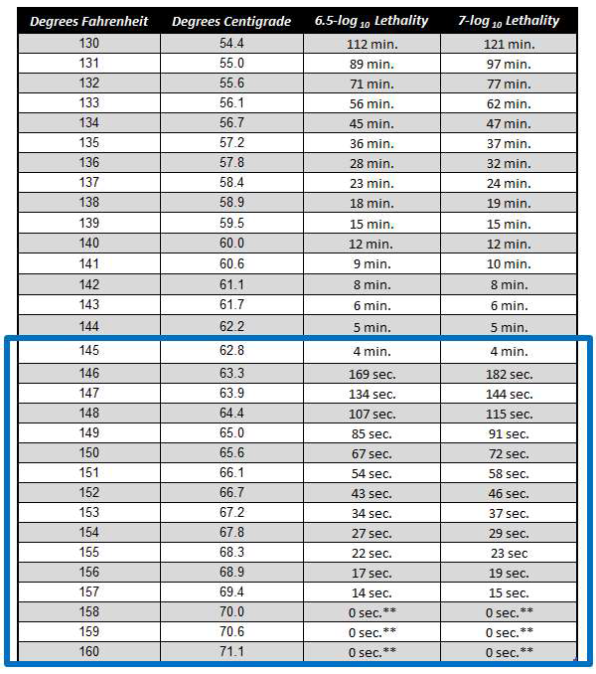

Table 4. Time-Temperature Combinations for Turkey Products to Achieve Lethality

Times for given temperatures and fat levels that are needed to obtain a 7-Log reduction of *Salmonella* in turkey products*.11* As described on page 23, **relative humidity**12 and heating **come-up-time (CUT)13** are **critical operating parameters** when using this table.